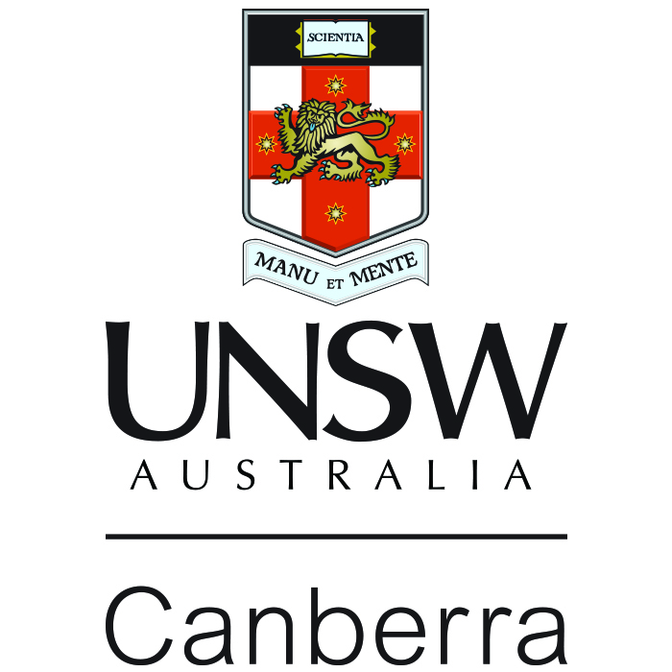

UNSW Canberra

List of Research Areas and Potential Supervisors for MPhil thesis
under the UNSW-XJTU Double Masters Program

School of Business(http://bus.unsw.adfa.edu.au/research/)

Economics of peacekeeping, International trade, Economic growth, Economic development, Economic problems faced by small island states and financial and public sector reforms
Prof Satish Chand (http://bus.unsw.adfa.edu.au/staff/profiles/chand-satish.php)

Human Resource Management
Prof Michael O’Donnell (http://bus.unsw.adfa.edu.au/staff/profiles/odonnell-michael.php)

School of Engineering and Information Technology Research Report (http://seit.unsw.adfa.edu.au/pdf/SEIT%20Research%20Report%202011_Final.pdf)

Aerospace Engineering, Engineering Instrumentation
A/Prof Harald Kleine (http://research.unsw.edu.au/people/associate-professor-harald-hermann-kleine)

Aerospace Materials, Composite Materials, Numerical Modelling and Mechanical Characterisation
Prof Paul Hazell (http://research.unsw.edu.au/people/professor-paul-j-hazell)
Prof Evgeny Morozov (http://research.unsw.edu.au/people/professor-evgeny-morozov)

Autonomy and control of unmanned aerial vehicles, Biologically inspired robotics, Sensor fusion
Dr Matt Garratt (http://research.unsw.edu.au/people/dr-matt-adam-barry-garratt)

Flapping Wing Propulsion and Power Generation, Unsteady Aerodynamics of Insect Flight, Micro-air Vehicles
Prof Joseph Lai (http://research.unsw.edu.au/people/professor-joseph-lai)
Dr John Young (http://research.unsw.edu.au/people/dr-john-young)

Fluid Physics, Aerospace Engineering, Nonlinear Optics and Spectroscopy
Dr Sean O’Byrne (http://research.unsw.edu.au/people/dr-sean-obyrne)

Hypersonic Propulsion and Aerodynamics, Computational Heat Transfer, Biomechanics
A/Prof Andrew Neely (http://research.unsw.edu.au/people/associate-professor-andrew-james-neely)

Image Processing, Biomedical Engineering, Video Communications, Biomedical Instrumentation
A/Prof Mark Pickering (http://research.unsw.edu.au/people/associate-professor-mark-pickering)

Information and Computing Sciences, Networking and Communications
Prof Jiankun Hu (http://research.unsw.edu.au/people/professor-jiankun-hu)

Lasers and Quantum Electronics, Quantum Optics
Prof Elanor Huntington (http://research.unsw.edu.au/people/professor-elanor-harriet-huntington)
A/Prof Charles Harb (http://research.unsw.edu.au/people/associate-professor-charles-charbel-harb)

Neural, Evolutionary and Fuzzy Computation, Logistics and Supply Chain Management, Optimisation, Operations Research
Prof Hussein Abbass (http://research.unsw.edu.au/people/professor-hussein-abbass)
A/Prof Ruhul Sarker (http://research.unsw.edu.au/people/associate-professor-ruhul-sarker)
Dr Tapabrata Ray (http://research.unsw.edu.au/people/dr-tapabrata-ray)

Quantum Robust, Nonlinear and Stochastic Control Theory
Prof Ian Petersen (http://research.unsw.edu.au/people/scientia-professor-ian-richard-petersen)

Control theory & Control Applications, Smart Structures, Modelling and Active Control of Noise and Vibrations
A/Prof Hemanshu Pota (http://research.unsw.edu.au/people/associate-professor-hemanshu-pota)

Large-scale interconnected systems, decentralized and distributed control, Stochastic Stability and Control, Robust Stability and Control
A/Prof Valeri Ougrinovski (http://research.unsw.edu.au/people/associate-professor-valeri-ougrinovski)

Structural Engineering, Numerical Modelling and Mechanical Characterisation
Dr Mahmud Ashraf (http://research.unsw.edu.au/people/dr-mahmud-ashraf)

Wireless communications, Digital Signal Processing, Underwater Communications
Prof Michael Frater (http://research.unsw.edu.au/people/professor-michael-frater)
Dr Mark Reed (http://research.unsw.edu.au/people/dr-mark-craig-reed)

School of Humanities and Social Sciences Research Report (http://hass.unsw.adfa.edu.au/pdf/HASS-Research-Report-2011.pdf)

Chinese Politics and Defence
Dr Jian Zhang (http://hass.unsw.adfa.edu.au/staff/profiles/zhang.html)

Non-traditional Security
A/Prof Anthony Burke (http://hass.unsw.adfa.edu.au/staff/profiles/burke.html)

School of Physical, Environmental and Mathematical SciencesResearch Report (http://pems.unsw.adfa.edu.au/research/pems_research_report_internals_0910.pdf)

Advanced Materials
Dr Wayne Hutchison (http://pems.unsw.adfa.edu.au/staff/profiles/hutchison)

Applications of advanced laser spectroscopies to chemical problems in the solid state
Prof Hans Riesen (http://pems.unsw.adfa.edu.au/staff/profiles/riesen)

Applied and Industrial Mathematics
A/Prof Harvinder Sidhu (http://pems.unsw.adfa.edu.au/staff/profiles/sidhu_h)

Astronomy and Astrophysics
Prof Warrick Lawson (http://pems.unsw.adfa.edu.au/staff/profiles/lawson)
A/Prof Chris Wright (http://pems.unsw.adfa.edu.au/staff/profiles/wright)

Biological Chemistry
Prof Grant Collins (http://pems.unsw.adfa.edu.au/staff/profiles/collins)

Biogeography, Environmental Management, Palaeoecology
A/Prof Stuart Pearson (http://pems.unsw.adfa.edu.au/staff/profiles/pearson)

Condensed Matter Physics
Prof Sean Cadogan (http://research.unsw.edu.au/people/professor-sean-cadogan)

Physical Oceanography in bays and estuaries
A/Prof Xiao Hua Wang (http://pems.unsw.adfa.edu.au/staff/profiles/wang_xh)

Social and transport geography
A/Prof Paul Tranter (http://pems.unsw.adfa.edu.au/staff/profiles/tranter)

Statistical mechanics of polymers and polyelectrolytes, liquid crystals, biomolecular modelling
A/Prof Cliff Woodward (http://pems.unsw.adfa.edu.au/staff/profiles/woodward)

Water treatment and purification, Experimental and theoretical study of forces between surfaces andcolloidal particles
Prof Ric Pashley (http://pems.unsw.adfa.edu.au/staff/profiles/pashley)

